RELEASE DATE | GENRE | TARGET AUDIENCE | PLAYERS | Developer | SRC | BARCODE
April 02 | Multiplayer RPG |  | 1-4 |  | $69.95 | 4 005209 054089

In the far distant past the legendary Warriors of Light defeated the Forces of Darkness...  Since then the whole world has been living in peace.  However, changes are slowly affecting the lands, droughts and storms and even monsters have filled the world with despair.  In order to identify those who can save the lands and who have enough power to defeat the monsters, the King decides to hold a combat tournament.  At the same time as he wisely fortified the defenses of the country! | 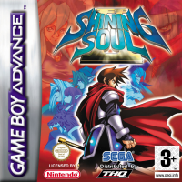

Unique four-player RPG action
- Multiplayer elements and action characteristics have been greatly
enhanced inc multiplayer battle
- Player character can be selected from Swordsman”, “Mage”, “Archer”
“Dragonnewt” “Fighter”, “Monk”, “Ninja” and “Wizard
- Pre-prepared quests inc. rescue and seek quests
- Over 4 times more collectable items than Shining Soul.
- Excellent collection and exchanges system
- Character designs by the famous Mr. Yoshitaka Tamaki



